**The Secrets To Selecting High Reward Setups**

This teaching will be a micro of the trading plan development series ICT doesnt look at all the things in the trading plan development series

The ICT mindset is a collective whole, processed thinking

Where are we building on? Are we going to buy or sell or stay on the sidelines? What is the process?

Experience will define when not to trade

A narrative has to be binary, very defined. If you dont have a plan then this will lead to impulsive emotional trading.

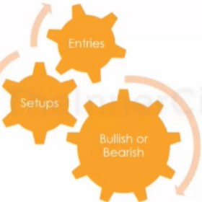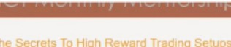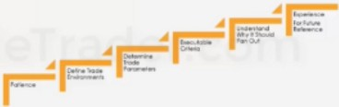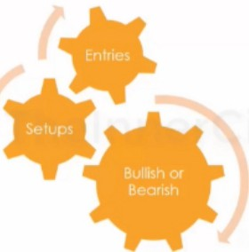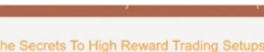A trading plan is unique to everybody, dont share it with others

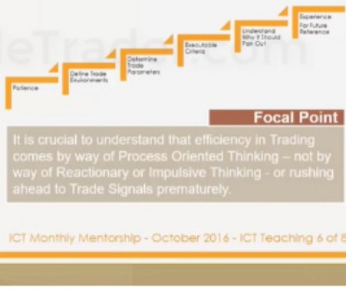

Entries are not what you need to know right now, you need to develop a process orientated thinking first. You need total understanding

The people that are struggling are reactionary and impulsive of what they want to do right now, beginners want to immdeiately get in and start trading. You dont know what defines the trade setups yet, it comes by experience and by seeing ideas

Stop looking to do something right now, professional traders are not in a rush, they sit back and wait for a scenario that makes sense

All decisions ICT makes before a trade he will share, he has experience and uses processed thinking



* • -

**re ,-.,spectt**

**oMarket**

--**v**

**rHl leAn**

==**llly$**

**Ol'lal lnfluene**

**f**

--

._._...,

**f**

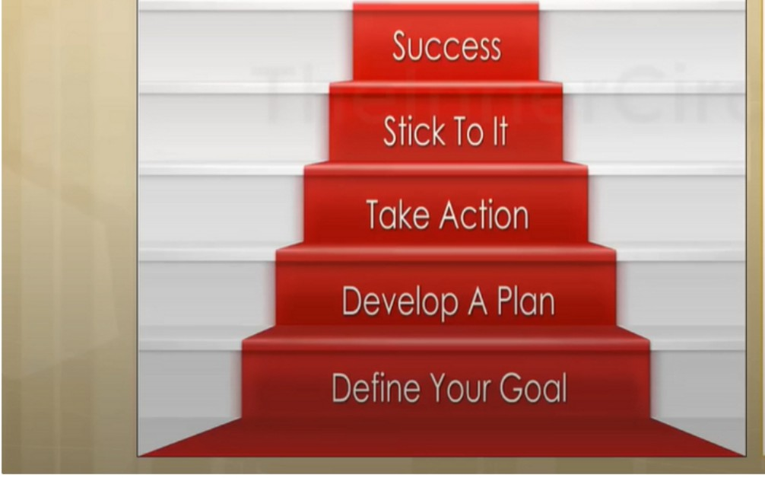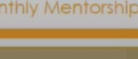



**·:ira Trading Setups**

**Big Picture Perspective:**

Macro Market Analysis Interest Rate Analysis lntermarket Analysis Seasonal lnnuences

**Intermediate Perspective:**

Top Down Analysis COT Data

Market Sentiment

**Short Term Perspective:**

Correlation Analysis Time & Price Theory

IPDA- Interbank Price Delivery Algorithm



•

**ligl'k:turel'.,sp«ffve:**

--

**MaaoMarl<el**

**'"'-NtRaleMIPtM**

•

**Ilg l'lctv e·**

**Macr**

**lnle 1s**

--

__

,

**5eal**

Primarily focus on 2 that have to come to agreement, not all 4 have to agree.

Inflationary and deflationary markets have big impacts on stocks and commodities as well Caring change market, 2 markets interest rates

When your big picture, intermediate and short term perspective are all in agreement then thats what makes a high reward trading setup

**.ta**

-***__***I***.,***r***_ ,_***.***"***

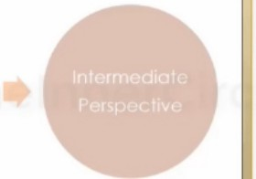

•

**lnlenn•dlote l'e,spacffve:**

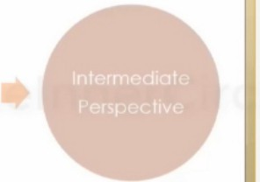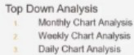

•

**lnl«me>diale 1'11r1p.cllve:**

**COTO**

•

---

.***°'***.***"***,***1***

Again 2 have to be in agreement lntraday charts have no effects on price

Daily weekly and monthly are what move price Top down analysis we need 2 in agreement

ICT does saturday studies, to see where price wants to go The least of significance is market sentiment

**.&,-.T'-'**

-·-

--

-

|  |  |  |  |
| --- | --- | --- | --- |
|  | •  ·•• | $hott T...-m**,et5pecttve:** |  |

For short term we need 3 to be in agreement



·•

•

**Shor!Term,eft,peeli¥e:**

**r... f'**

,.._

**r-010.,-**

•

*IPOA-==== ...-­*

==,,_,.,..

-

Every 3 months, theres a new price shift. If the market has been going higher youll probably see the market go in consolidation, not the entire 3 months.

Preferably 1 from each

Executing trades will be tiny of your time, the most time youll spend is finding out wether you want to be a buyer or seller

This is the context of where are area of interest will be and what well be learning

Big perspective and intermediate perspective is going to be set on the weekend prior to the next trading week

Short term perspective can switch daily

When ICT calls out a move, theyre mostly derived from his big and intermediate perspective

As a day trader short term trader and one shot kill, ICT uses mostly the short term perspective page

The big picture and intermediate perspective is where less losses come from

In total 7 things have to be in agreement, thats high reward setups. This will give you clarity Entry signals are the least of your concern

This is the routine you go trough

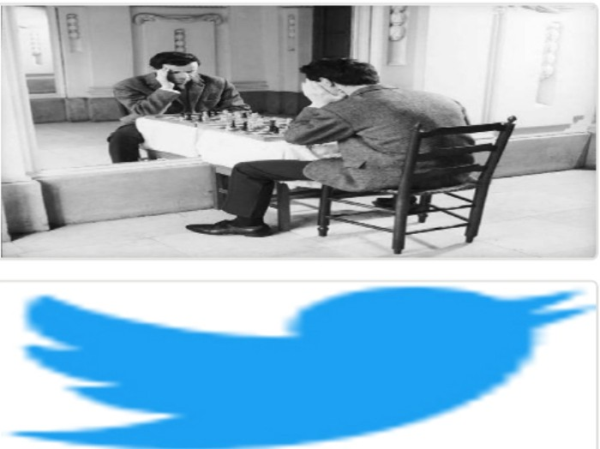Arjo I Twitter, lnstagram I Linktree

Linktree. Make your link do more.

1 https://t.co/HhmmTN1fUI

JavaScript is not available.

***"JI*** https://twitter.com/arjoio